What is RPC?
RPC is an acronym for Remote Procedure Call, which involves executing what appears to be a normal, local, procedure call (method invocation); but, instead, sending network packets to a remote host.

The remote procedure call (RPC) paradigm [BJ Nelson, CMU, 1981] and [AD Birrell and BJ Nelson, 1984] is based on the observation that procedure calls are a well understood mechanism for control transfer.

The proposal is that procedure calls may be consistently extended to access remote environments (other machines). When a remote procedure call is invoked :
• The calling environment is suspended,
• Any parameters are passed (marshalled) across the network to the remote environment,
• The required procedure is executed in the remote environment,
and
• Results are marshalled back to the caller and its execution resumes.
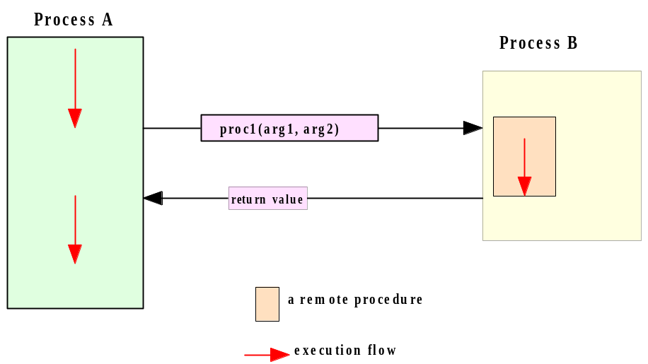

Since its introduction in the early 1980s, the Remote Procedure Call model has been widely in use in network applications.

There are two prevalent APIs for this paradigm.

the Open Network Computing Remote Procedure Call, evolved from the RPC API originated from Sun Microsystems in the early 1980s.

The other well-known API is the Open Group Distributed Computing Environment (DCE) RPC.

Both APIs provide a tool, rpcgen, for transforming remote procedure calls to local

The RPC Execution Order
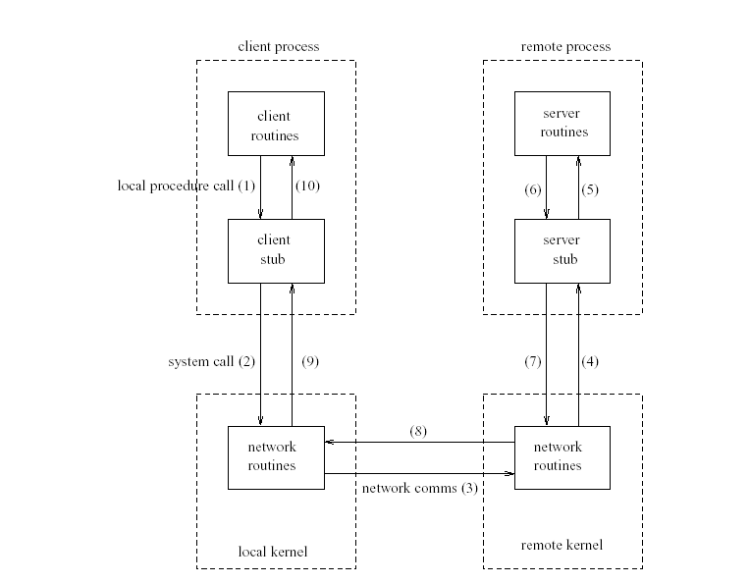
1) The client calls a local procedure termed the client stub. It appears to the client that the stub is the actual server procedure that it wants to call. The purpose of the stub is to package up the arguments to the remote procedure, possibly put them in some standard form and then to build one or more network messages (marshalling).
2) The network messages are sent to the local kernel using a system call.
3) The network messages are sent to the remote kernel using either a connection based or connectionless protocol.
4) The server stub has been waiting on any client’s request. It unmarshals the arguments from the network messages and possibly converts them to its own (architecture’s) format.
5) The server stub executes a local procedure call to invoke the actual server function.
6) When the server procedure is finished it returns (normally) to the server stub, returning any required arguments.
7) The server stub converts the return values, if necessary, and builds one or more network messages.
8) These messages traverse the network.
9) The client stub reads the replies from the local kernel (it has blocked all this time).
10) After possibly converting the return values the client stub returns to the calling procedure; control flow is again in the client’s code.

The Jrpcgen Protocol Compiler

The details of programming applications to use Remote Procedure Calls can be overwhelming. Perhaps most daunting is the writing of the XDR routines necessary to convert procedure arguments and results into their network format and vice-versa.

Fortunately, Jrpcgen exists to help programmers write RPC applications simply and directly. JRpcgen does most of the dirty work, allowing programmers to debug the main features of their application, instead of requiring them to spend most of their time debugging their network interface code.

Jrpcgen is a compiler.( It is the Java version of the rpcgen complier which you would use if you were writing an RPC program in the C language).

Jrpcgen accepts a remote program interface definition written in a language, called RPC Language (i.e. XDR IDL), which is similar to C/Java. It produces a Java language output which includes stub versions of the client routines, a server stub, XDR filter routines for both parameters and results. The client stubs interface with the RPC library and effectively hide the network from their callers. The server stub similarly hides the network from the server procedures that are to be invoked by remote clients.

Jrpcgen’s output files can be compiled and linked in the usual way. The developer writes server procedures—in any language that observes Sun calling conventions—and links them with the server skeleton produced by Jrpcgen to get an executable server program.

To use a remote program, a programmer writes an ordinary main program that makes local procedure calls to the client stubs produced by Jrpcgen. Linking this program with rpcgen’s stubs creates an executable program. Jrpcgen options can be used to suppress stub generation and to specify the transport to be used by the server stub.

Like all compilers, Jrpcgen reduces development time that would otherwise be spent coding and debugging low-level routines. All compilers, including Jrpcgen, do this at a small cost in efficiency and flexibility.

The Jrpcgen compiler and all supporting classes are part of the Distinct ONC RPC/XDR Toolkit for Java Version 6 which you should have installed on your machine.

Converting Local Procedures into Remote Procedures (The RPC Language)
Assume an application that runs on a single machine, one which we want to convert to run over the network.

Here we will demonstrate such a conversion by way of a simple example—a procedure (method) that echo’s back a number one less than the number passes to it as an argument.

Here is the procedure:

public int echo (int a)
{
return(--a); // returns the number decremented by one
}

If echo() was turned into a remote procedure, then it could be called from anywhere in the network.

Ideally, one would just like to stick a keyword like remote in front of a procedure to turn it into a remote procedure. Luckily it’s not very difficult to make a procedure remote.

In general, it’s necessary to figure out what the types are for all procedure inputs and outputs. In this case, we have a procedure echo() which takes an integer as input, and returns an integer as output.

Knowing this, we can write a protocol specification in XDR Interface Definition Language (IDL) that describes the remote version of echo(). The IDL defines the procedure but does not include any implementation. Here is the XDR IDL for the procedure:

program ECHOPROG {
version ECHOVERS {
int echo(int) = 1;
} = 1;
} = 77;

(Note that the program, version and procedure all have ID numbers.)

Remote procedures are part of remote programs, so we actually declared an entire remote program here which contains the single procedure echo. This procedure was declared to be in version 1 of the remote program.

Notice that everything is declared with all capital letters. This is not required, but is a good convention to follow.

Data Transfer from Client to Server
Significant problems are introduced with parameter passing. Passing simple data types (by value) such as integers, floating point numbers and strings (character arrays) is easy. The client-stub simply places copies of them in a calling packet.

At worst, data types may need format conversion between machines (performed by the Transport Layer). There exists a well defined data interchange standard - the External Data Representation (XDR) for transferring data between heterogeneous
Environments.

In the example above the echo procedure (method) is passed an integer and returns an integer. However the procedure will be a remote procedure which means that it will be located on another machine (e.g. a unix machine or a VAX, OS X, Linux).

This machine may define integers differently to the client (e.g. the client may represent integers as little-endian while the server which holds the routine may represent integers as big-endian. In order that data is properly transmitted and understood we need a standard representation of the data. We use XDR to do this.

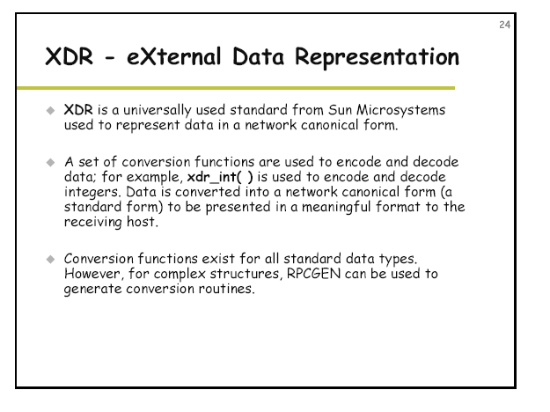
When data is transferred from one machine to another it is mapped to an XDR type as follows:

XDR Type | Java Type
(unsigned) int | int
(unsigned) long | int
(unsigned) short | short
(unsigned) char | char
(unsigned) hyper | long
float | float
double | double
bool | boolean
string | String
opaque | byte array
fixed length array | Java array
variable length array | Java array
optional data (pointer like *x) | Reference to an object of class x. If x is a basic type a special wrapper class XDRx that implements XDRType is used instead.
enum x | Class x implements XDRType with member variable int value and one constant int per enum constant.
struct x | Class x implements XDRType with member variables for each struct member.
union x | Class x implements XDRType with member variables for each union member including discriminant. No overlaying of members is supported (neither for type conversion nor for saving space).
typedef x y | Class x implements XDRType with member variable value of the redefined type y.

You will see the use of XDR in the stub and skeleton below.

Exercise 1:
Write the XDR IDL protocol specification for the echo program above in a file called echo.x.

Now, from a dos window we will compile the file as follows
>java Jrpcgen –S < echo.x
(if this doesn’t work try: > java Jrpcgen –S < echo.x. You will need to edit ECHOPROG.java and change echo to ECHOPROG and echoclient will need to instantiate an ECHOPROG object)

This will generate two files, a client stub (ECHOPROG and a server stub
ECHOPROGServer.java. Another name for these types of files are proxies.[Note: stub = proxy]

The Jrpcgen compiler will generate two files for you – a client stub and a server stub.
The client stub is used by the client application to marshall the parameters (i.e. map them to XDR format, and then call the remote procedure across the network.

The server stub will receive the call, unmarshall the parameters and call the actual procedure and return the results to the client.

The diagram below shows what is happening: a) a local procedure b) a remote procedure
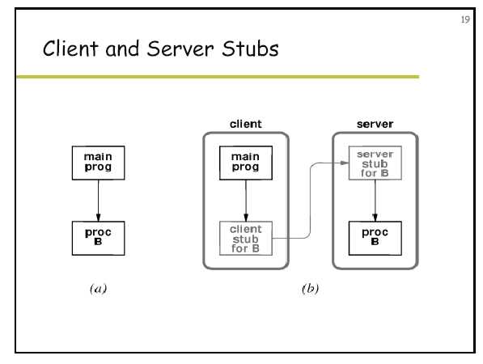

The stubs will interact with the RPC library which will in turn interact with the network layers to send the message.

